Chapter 3 p.64

Chinese state media influencers breakdown by language grouping

Social media influencers target seven audience spaces (language groupings) worldwide that are separated into geographic regions. No charts shown for English or Chinese-language audience spaces.

These charts show numbers of influencer profiles by language grouping. Each influencer profile features real people employed by Chinese state media to tell China’s story on social media.

Pie chart showing the numbers of Chinese state media influencers by language grouping in Asia. It shows Hindi, Tamil, and Khmer: 3; Burmese, Malay, Urdu, Thai, and Korean: 4; Vietnamese and Lao: 5; Pashto and Sinhala: 6; and Other: 10.

Pie chart showing number of Chinese state media influencers breakdown by language grouping in Europe. It shows Czech: 2; Italian, Greek, Esperanto, and Russian: 3; German: 4; Other: 5; and French: 14.

Pie chart showing number of Chinese state media influencers breakdown by language grouping in Africa. It shows Swahili: 3, Hausa: 7.

Pie chart showing number of Chinese state media influencers breakdown by language grouping in Middle East. It shows Persian: 5, Turkish: 6, Hebrew: 9, and Arabic: 17.

Pie chart showing number of Chinese state media influencers breakdown by language grouping in Latin America. It shows Portuguese: 5 and Spanish: 5.

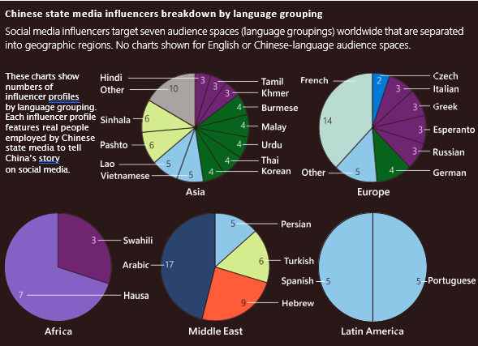

Source: Microsoft Threat Analysis Center investigations